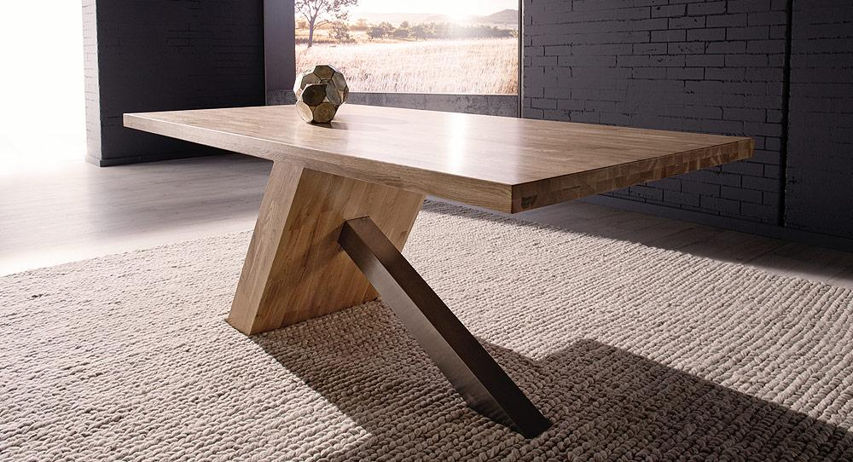

Financial Statement Analysis----- Group Assignment 1
Industry and Strategy Analysis

Long Wu 11577879
Xiaoyu Huang 11807587
Rongwei Pan 11521628
Gurnoor Singh 11809175
Liangda Huang 11670585

Contents
1. Introduction 3
2. Macro economy analysis 3
2.1 GDP Analysis 4
2.2 Inflation Analysis 5
2.2 Foreign Exchange Analysis 6
3. Industry Analysis 7
3.1 Competition in the industry--- High 7
3.2 Threat of New Entrant--- Low 8
3.3 Threat of substitute product --- Moderate. 8
3.4 Bargaining power of buyers—strong. 9
3.5 Bargaining power of suppliers – moderate/ low. 9
4. Successful factors 10
4.1 Focus on Profitability 10
4.2 Store expansion 10
4.3 Positioned as a discount retailer 11
4.4 Employee diversification 11
5. Risk Factors and Risk Management 12
5.1. Foreign Currency Risk 12
5.2. Credit Risk 13
5.3. Foreign currency translation 13
5.4. Derivative financial instruments 13
5.5. Risk Management Activities 14
6. Sustainability 14
7. Conclusion 16
8. Reference 17

Introduction

Recently, furniture companies have a huge expansion over the world. Nick Scali Limited, a publicly listed company in Australia, imports and retails furniture such as coffee tables, lounges, dining tables, chairs and entertainment units. This essay will discuss macro-economic factors, and describe how these factors can impact Nick Scali Limited. At the same time, it will also identify the competitors and alternative products, use this method to analyse the consumer electronics industry. Finally, corporate strategic analysis report will regressed internal and external with success strategies and the potential risks.

Macro economy analysis

Nick Scali Limited, henceforth NCK, is an Australian public company and one of Australia’s largest importers furniture and one of the largest retailers as well. In recent years, the company NCK has already experienced a series of changes in its structure and operations. NCK operates 39 department stores exclusively in Australia (see Table 1.1), comprising 34 Nick Scali stores and 5 Sofa stores. It has generated 141.4 million in sales revenue and 14.2 net profit in 2014 (Nick Scali annual report, 2014). However, the industry analysis that involves how macro-economic factors have impacted the historic performance of Nick Scali Limited, and how the company should be expected to impact Nick Scail Limited performance in the future. There are three most important factors to consider for Nick Scali that are Gross Domestic Product (GDP), inflation rates, interest rates and foreign exchange rates
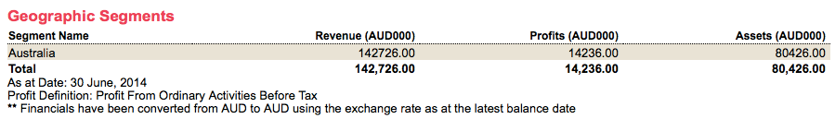

GDP Analysis

GDP for the past 20 years in Figure 1.1 is shown that the blue line representing GDP on a year-on-year basis. Relatively speaking, since 2008-2009, the Australia GDP was absolutely suffered by the Global Financial Crisis (GFC), and then GDP growth dropped alarmingly, reaching the lowest point at around 1.5% to 2.0% as shown in the graph. At the same time, based on the figure1.2, Nick Scali Limited sales revenue has sharply fallen by around 5% as mentioned on the graph (IBISWORLD, 2014). However, in 2013, the Australian gross domestic product (GDP) recovered alarmingly and increased to the peak at around 4.5% (ABS 2014). Nick Scali Limited revenue had increased by 25%. This will result in the Nick Scali profit is expected to have upward trend.
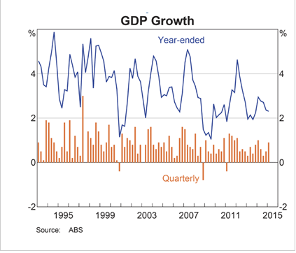
Figure 1.1 GDP 1995-2015 (RBA 2015)
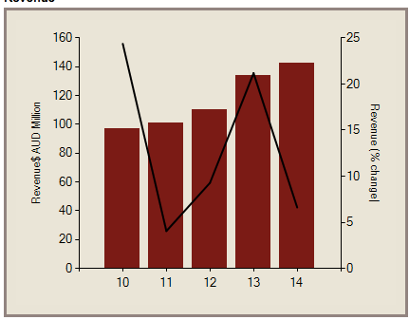
Figure1.2 Revenue changes during 5 years (ISIBWORLD 2014)

2.2 Inflation Analysis

Inflation is measurement of the increase in the general level of prices over time.The sustainable range of inflation is between 2 and 3 per cent per year (Reserve Bank of Australia). According the Figure2 the inflation rate keeping around in 2 to 3 percentage from 2010 to 2015. Moreover, to control inflation and other aspects of the economy, the RBA meets monthly and set the cash rate, which is the rate that financial institutions pay to borrow, or charge to lend funds in the overnight money market. In the context of Nick Scali, inflation and interest rates have an indirect effect on the demand for their products. High inflation results in a higher than average increase in the cost of expenses. As a result, in times of high inflation, it would be expected that Nick Scali products would receive lower than average demand. The same result may be expected with high interest rates. If the cash rate goes up, so many consumers have to do interest rate on loan, and individuals are facing the size of their repayments increase with variable rate loans. This means that many consumers have to pay attention to spend repaying interest through a higher portion of household income, and less household income is spent on discretionary expense such as luxury furniture goods.
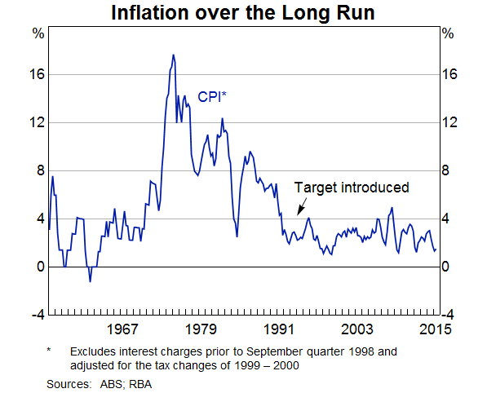
Figure 2.1 Inflation rate from 1967-2015 (RBA 2015)

Foreign Exchange Analysis

Nick Scali Limited is one of the largest furniture retailers in Australia and relies heavily on imported products paid in overseas. According to the Nick Scali Annual Report of its operating and financial review in 2014, Nick Scali Limited faces the risk of a decrease in the overseas exchange rates such as AUD/USD exchange rate, as is illustrated in Figure3. In recent times, the Australian dollar has been dropped sharply against in the overseas currency. As we known to everyone, there are almost all popular and famous retailers are all from Australia, such as Harvey Norman, Fantastic Holdings and Freedom furniture. Due to the Australian dollars have devaluated drastically, many Australian citizens are likely to consider a lower and cheaper price for these product compared with other country. This will be a reason of an increase in Nick Scali Limited revenue and profit. In addition, a lower currency that causes a higher investment in the future. Therefore, the foreign exchange rate is important factors for Nick scali Limited.
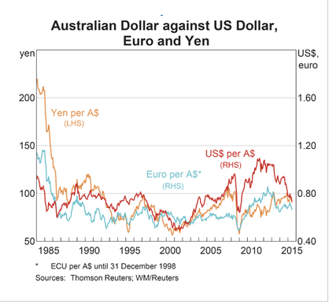
Figure 3 Australian Dollar Against US Dollar (RBA 2015)

Industry Analysis

According to the Porter’s Five Forces framework, the majority of organizations are used for strategic industry analysis. Therefore, the below industry analysis of Nick Scali will be used through Five Forces Framework by Porter to analyse the competitiveness of Nick Scali. In addition, the market share and profitability of Nick Scali is threaten by its ambiguous positioning within the Australian market (Jim Wilkinson, 2013)

3.1 Competition in the industry--- High

Competitive conditions are one of critical elements in industry analysis for the retailer of furniture, which has various types of products and homogenous stores. For instance, there are numbers of homogeneity of stores in Australian markets, which specially sells furniture products such as Harvey Norman and Fantastic Holdings that are strong competitors of the Nick Scali Limited. On the other hand, there are many different types of furniture products. Moreover, a number of companies increasingly produce furniture products and even the same type of furniture products. Tim McArthur (2013) shows that due to so many traditional bricks-and-mortar furniture retailers in Australian retail markets lead to the furniture has been sharply dropped in recent years. As IBISWorld estimated that only 3.7% of domestic furniture sales are carried out online. However, online household furniture sales are increased annually by around 17.8% in the five years through 2013-14, the profit margin to reach $297.5 million. Compared with traditional bricks-and-mortar furniture retailers that are expanded at around 1.1% in annually over the same period.
If a retailer of furniture has a good and unique competition strategy, which distinguish to other companies. For instance, there are some main competitor, namely is Harvey Norman for Nick Scali, it still sustain a leading position. According to Nick Scali Limited Annual Report (2014), Nick Scali creates their special competition strategies. They keep operating a low designed cost model to strengthen competitive pricing at the store level. Furthermore, Nick Scali continually operates their new retail stores. This would lead to easily increasing NCK market shares by lots of furniture retailers that are going online (Matthew Smith, 2013). While Nick Scali continually opens their new stores since they may attach significance to boost the efficiency and profitability of existing stores. Based on these unique competitive strategies, Nick Scail can keep a leading position in retailer of furniture products field.

3.2 Threat of New Entrant--- Low

Threat of new entrants is one of the significant forces that form the competitive structure of an industry, focusing on threat of new entrants that comprise with a high and low threat of entry. However, a high threat of new entry which means there are many new competitors no matter what companies are likely to be attracted to the profits of the industry and can easily enter the industry. Moreover, threatening or decreasing the market share and profitability of existing competitors and also can change existing product quality or price levels due to most of new competitors enter to the market. On the other hand, a low threat of new entry entering to the marketplace, most of new competitors less competitive and increasing the profits for the existing firms (Jim Wilkinson, 2014)
In Australia marketplace, there are many well-known and grown-up retailers of furniture such as Harvey Norman, Nick Scali, and Fantastic Holdings. These retailers usually have to compete price levels and promotion with other competitors. As we known that the Australian furniture market has been saturated. Consequently, it is difficult that a new entrant enter to the marketplace. For example, Beth Greene (2014) shows that some smaller furniture companies are facing barriers to attract customers when they enter to a furniture market since large and well-known furniture retailers can make it difficult. In addition, the large company in Australia, like Nick Scali, has ability to reduce their manufacturing costs and provide low prices for furniture. Therefore, this would result in less chance to earn profits for new entrants.

3.3 Threat of substitute product --- Moderate.

Relative price and performance and buyer’s willingness to switch: the main substitute for Nick Scali furniture firm is IKEA which are bigger wholesale store. A brand such as IKEA directly compete with Nick Scali, but the furniture lounge sold at IKEA performs the same functions as the Lounge at Nick Scali. A customer who substitutes Nick Scali with IKEA as their source of lounge would pay less, but would receive lower quality lounge and customer service. The threat of downgrading to standard quality clothing would be great in an economic downturn.

3.4 Bargaining power of buyers—strong.

As the competition is intense and the customer has a wide of alternative options offered by global furniture retailers, as well as, Australia local furniture producers.
Price sensitivity: The middle market of furniture industry is full of companies that focus on differentiation of their product. At the high end of the good quality furniture industry, price sensitivity for buyers is relatively low, and prices are highly dependent on the quality of products and the image associated with particular brands of products. At the lower end, where Nick Scali is situated, differentiation is lower and buyer price sensitivity is higher.
Relative bargaining power: The good quality furniture industry has a relatively high turnover for its products. This weakens bargaining power, because the loss of the business of individual customers is not particularly high. That being said, the low switching cost of customers provide them with a degree of bargaining power, giving them greater demand over price

3.5 Bargaining power of suppliers – moderate/ low.

Bargaining power of suppliers is a significant force within this model, that it needs raw materials as input to company’s process. The power of suppliers operates conversely to the power of buyers. Overall, suppliers in the middle market furniture industry have relatively low power. Despite the differentiated nature of the products within the market, the fierce competition between firms and relatively low barriers to entry have created an industry where growing profits and market share are very difficult.

4. Successful factors

4.1 Focus on Profitability

In the end, no company can survive without continuous profitability. A furniture company will spend plenty of expense, which includes fixed expense such as rent and electricity. In Nick Scali Limited's budget, it should contain these fees and any petty disbursement which is used to keep the satisfaction of clients. Figure 4 below shows that Nick Scail has the continuous profitability.
In determining the pricing for the furniture products, be sure to include the fees in product retail prices. Create a price for the business in a rapidly changing economy will keep the furniture when company earnings, allowing accidents and mistakes, as well as wages and volatility of fuel and transportation costs.

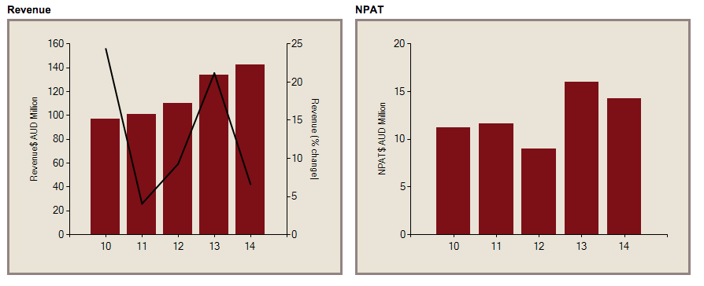
(Figure 4) Revenue and NPAT graph

4.2 Store expansion

Nick Scali Limited expanded its store networks by opening 5 new stores in eastern areas of NSW, Queensland and Victoria (Lawrence, 2013). Assisted by the maturing of stores opened in previous years, these new stores have accomplished a great increase of sales revenue (up to 10% of previous year).

4.3 Positioned as a discount retailer

One of the main success factors is that Nick Scali Limited provides a wide range of high quality products with discounted price lower than other retailers. This is because of its good relationship with suppliers, high level of turnover, low cost of operation and benefits of scales. Figure 4.2 showed below. Nick Scali has competitive price advantage over Fantastic Holdings (ASX:FAN) and Harvey Norman (ASX; HVN) which are the competitors of Nick Scali.

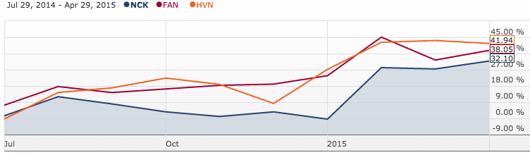
Figure 4.2 share price

4.4 Employee diversification

Nick Scali Limited's purpose is to ensure that every employees have access to equality in the workplace, regardless of race, age, gender, cultural background or other differences. This recognition of the unique contribution people can make, because of their different skills and personal backgrounds, experiences and perspectives. Different people is not only in culture and gender, but also have other dimensions, such as age, education, family responsibilities, lifestyle and physical fitness.

5. Risk Factors and Risk Management

The Nick Scali financial report complies with Australian Accounting Standards. The financial report also complies with International Financial Reporting Standards as issued by the International Accounting Standards Board. As the firm operates outside the main functional currency (Australian $), it has exposure to many types of market risks. Market risk can be defined as that risk which arises as a result of the changes in interest rates and foreign exchange rates related to the functional currency used by the firm in case. Such changes are anticipated to make possible losses to the profitability of the firm I question or the assets of the firm would depreciate in value. The primary objective of risk management is to manage and monitor market risk exposures within acceptable parameters, whilst optimising the return on risk. The Nick Scali firm has exposure to credit risks, liquidity risks, interest rates risk and foreign exchange risks.

5.1. Foreign Currency Risk

Most of the firm’s sales are in Australian dollars whereas most of the purchases are in USD. This means in the payment of stock purchases the firm as considerable amount of risk paying inflated amounts in case the foreign exchange differs between the date of purchase and date of payment. To eliminate or minimise the risk arising out of changes in the exchange rates the firm has entered into forward currency contracts in the form of options and forwards to manage the exposure in a suitable manner. The firm has also used hedging instruments to hedge against losses from such transactions. As of 30 June 2014, the Company has in the balance sheet an amount of trade payables equal to $1,693,601 and the amount was around $1,869,666 for 2013 and a further stock in transit of $3,561,420 (2014) and all these are covered by designated cash flow hedges. As a result of these arrangements the firm’s sensitivity to changes in the exchange rate in favour of US$ in quite minimal. All forecasts transactions are highly likely to occur and as a result the firm’s assets exposure are high.

In relation to this it is duly noted that the form has made certain adjustments in the comprehensive statement of income related t these risky assets and the cash flow hedge that was undertaken. The firm has suffered a loss of $723,000 related to the Cash flow hedges in 2014, whereas the firm made a gain of $661,000 in 2013. So it becomes imperative for the firm to make further arrangements to eliminate and reduce such probable losses in the coming years.

5.2. Credit Risk

Credit risk for Nick Scali can be defined as the risk of non-payment (default) arising out of counterparty guarantee. Most of the firm’s revenue comes from cash sales, however if a party is given credit, then that was given after assessing the standing of the party and its previous dealings with the firm. All the credit amounts in excess of 30 days are individually assessed and pursued for recovery and allowance for bad debt is created for those assessed to be non-recoverable.

5.3. Foreign currency translation

The firm has used the functional currency (Australian $) for reporting purpose and for this the assets and liabilities denominated in other currencies are converted in Australian dollars by using the appropriate exchange rates prevailing. All exchange differences are recognised in the statement of income, except when deferred in equity as qualifying cash flow hedges.

5.4. Derivative financial instruments

Nick Scali uses a variety of derivative instruments to hedge against possible losses arising out of changes in the market value of currencies and recognises the derivatives instruments at fair value initially and subsequently remeasures these instruments to their fair values on subsequent reporting dates to maintain continuity. As appropriate the firm either classifies them as fair value hedges or cash flow hedges.

5.5. Risk Management Activities

During the last fiscal, Nick scali designated the foreign currency forward contracts undertaken as hedges because of purchases of large scale inventories USD. The firm forecasted these purchases to occur between July and October. As a result, the Hedges were negotiated to match these purchase terms and transactions forecasted. Both the parties to such hedges have fully made cash collateralisation and thus eliminated any credit risk in such hedging transactions. Consequently, the hedges were assessed to be highly effective. As at 30 June 2014 the firm has reported an unrealised loss of $723,000 and as of 30th June 2013 the firm also reported an unrealised profit of $661,000 which is displayed in the statement of comprehensive income.

6. Sustainability

Due to the furniture market is more competitive, Nick Scali Ltd have to face more challenge from competitor and adjust company’s strategy to adopt competition and remain sustainable profit. Recently, some decision has been made to improve Sustainability profitability.
The first one is keeping traditional promotion strategy through investing huge amount of money in adverting on social media, TV advertising. James L (2015) points out the most important reason that Nick Scali Ltd has been dedicating to traditional marketing that has led them to being and ASX-listed leader in the retail area is the company invests huge amount of fund in advertising. A huge Wage of adverting for public will improve company reputation and enhance product reputation (James L, 2015). Also, it will take an advantage when customer is considering furniture purchase.

The second strategy is “online drives off offline” strategy. Nick Scali realised complement online sale with traditional offline sale could improve company’s revenue. Nick Scali approached The Showroom in 2012 to develop and online strategy to improve product sale. At the same year, they launched a new website to provide more detailed information about product range, collect potential customer data on products and give customer information about physical store location. However, It doesn’t mean Nick Scali Ltd facilitate online payment and encourage people shopping online. Customer still have to purchase Nick Scali Ltd’s furniture in the physical store. The only purpose to introduce online service is to promote offline sale through meeting customer’s demand that is a convenient way to know detailed product information (Anthony S, 2013). Through website customer is able to easily get the latest furniture, sale promotion information and discount information, which will appear more customer come to physical store doing some purchase and improve sales.
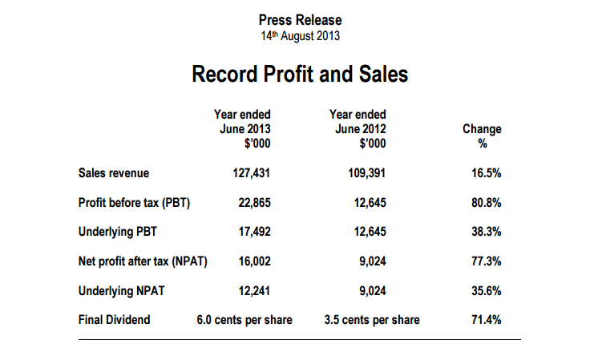
Figure 5 Profit and sales

7. Conclusion

With the feature to set up the analysis, it is important to determine the products and decide the rate of interests which are important for the employment policy as per the change in the growth, there are reflections on determining the weak and the strong country. To manage with the figures, it is important to analyse and handle the period of cycling which consume a proper level of inflation. (Ansolabahere et al., 2014). The measurement of the consumer price, there are selections of baskets and the services which rise above all the production level to manage with the employment feature. The tendency to move and calculate the supply generally handle the GDP growth rate which handles the salary of the employees as well as determining the supply rate under the employment feature. (Mattessich, 1977). The measure to hold an economy requires an important need of the transactions which measure the level of policy growth. The production level and the wages are important to absorb a proper supply of demand, thereby, taking care of all the interests’ rate factors.

8. Reference

Ansolabehere, S., Meredith, M., & Snowberg, E. (2014). Mecro‐Economic Voting: Local Information and Micro‐Perceptions of the Macro‐Economy.Economics & Politics, 26(3), 380-410.

Anthony S, 2013, Nick Scali Limited profit and sales, viewed 15 August 2015,http://www.nickscali.com.au/pdf_downloads/Final-Press-Release-FY2013.pdf

Beth, G, 2015, ‘Risk of Entry Into the Furniture Industry’, viewed 15 August 2015,
<http://smallbusiness.chron.com/risk-entry-furniture-industry-33458.html

IBIS World, 2015, viewed 16 August 2015, <http://clients1.ibisworld.com.au.ezproxy.lib.uts.edu.au>

Czinkota, M. R. (2011, 8TH EDITION). INTERNATIONAL MARKETING .CHICAGO:THOMSON- SOUTHWESTERN .

James L. 2013. ‘Nick Scali Furniture – A Case Study in Online Strategy Driving Offline Sales’, The Web Showroom. viewed 16 August 2015. <http://www.thewebshowroom.com.au/blog/nick-scali-furniture-a-case-study-in-online-strategy-driving-offline-sales/>

Jim, W, 2013, ‘Threat of New Entrants’, viewed 13 August 2015,
<http://strategiccfo.com/wikicfo/threat-of-new-entrants-one-of-porters-five-forces/>

KOTLER, P. (2012,14th Edition). Marketing Management. NewYork: Prentice Hall.

Nick Scali, 2014, Annual Report 2013-2014, Sydney.

Matthew, S, 2013, ‘Nick Scali spurns online for bricks and mortar strategy’, viewed 15 August 2015,
<http://www.brw.com.au/p/business/nick_scali_spurns_online_for_bricks_nUlskI7tINYgKHDwy6iEEJ>

Mattessich, R. (1977). Accounting and analytical methods: measurement and projection of income and wealth in the micro-and macro-economy. Scholars Book Company.

RBA, 2015, viewed 16 August 2015,<http://www.rba.gov.au>

Robinson, S. (1999). Measuring Service Quality: Current thinking and future requirements. Marketing Intelligence and Planning, Vol. 17, No.1, 21-32.

Tim, M, ‘online furniture sales to grow: are Harvey Norman, Fantastic and Nick Scali prepared’, viewed 10 August 2015,
<http://www.fool.com.au/2013/11/20/online-furniture-sales-to-grow-are-harvey-norman-fantastic-and-nick-scali-prepared/>

Vijayadurai, J. (2008). Service Quality, Customer Satisfaction and Behavioural Intention in Hotel Industry. Journal of Marketing & Communication, 14-26.

